Name___________________________

Seeing with Ears Lab Sheet

- Draw a sound wave in the box below.

- Draw how echolocation works. Use the features of the bat to show where the sound waves originate, travel and end up.
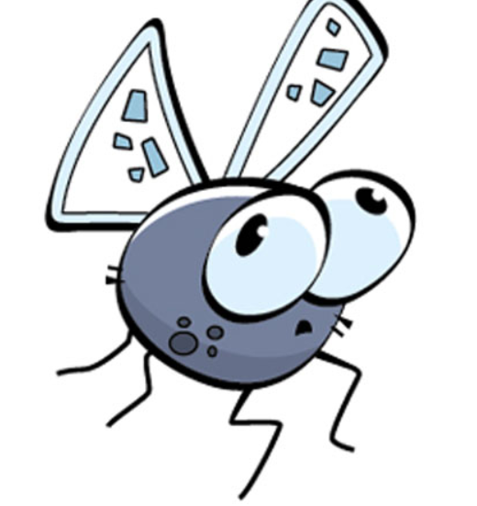
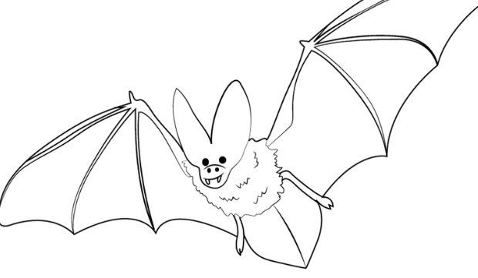
- Fill in the blank using the word bank below.

Echolocation helps animals _______________ things through _____________.
The animal produces a very ___________ pitched sound and listens for its echo.
Animals, such as _____________ and _______________ have developed special
___________________ adaptations that allow them to echolocate.
Animals that use echolocation can navigate, _______________, identify friends and
enemies, and avoid obstacles in complete __________________.

bats
high
locate
physical
darkness
dolphins
hunt prey
echoes

