Name:_________________________

Seeing My Night Sky- Homework 1

Directions:
Go outside at night and then answer these questions.

What time is it? ______________________________

Can you see the moon? Yes No
Can you see the stars? Yes No
Are there lights you can see from your night sky viewing spot?
List all the lights you can see from your night sky viewing spot
- ____________________________
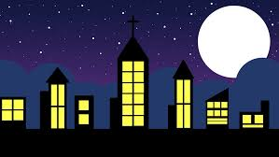
- ____________________________
- ____________________________
- ____________________________
- ____________________________
- ____________________________

Name:_________________________

Seeing My Night Sky- Homework 2

Directions:
Go outside at night and then answer these questions.

What time is it? ______________________________

Can you see the moon? Yes No
Can you see the stars? Yes No

Look around you for any source of light that is on. Is it a source you can turn off? If you can turn it off, do so. Now look at the night sky again. Is it different than before? How is it different?
________________________________________________________________________________________________________________________________________________________________________________________________________________________________________________________________________

